WebApp with MVC
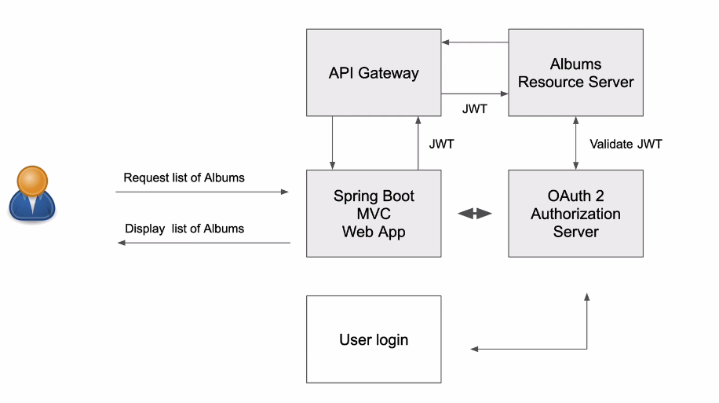
យើងប្រើ Jave ដើម្បីធ្វើការបង្កើត Web Application by Themlif

- Client request to the resource server to get the albums :
GET: /albums
- It need to have client to login to get the token then and Auth server give the credentials to the Clients then they can request to the resource server.

- Spring initial
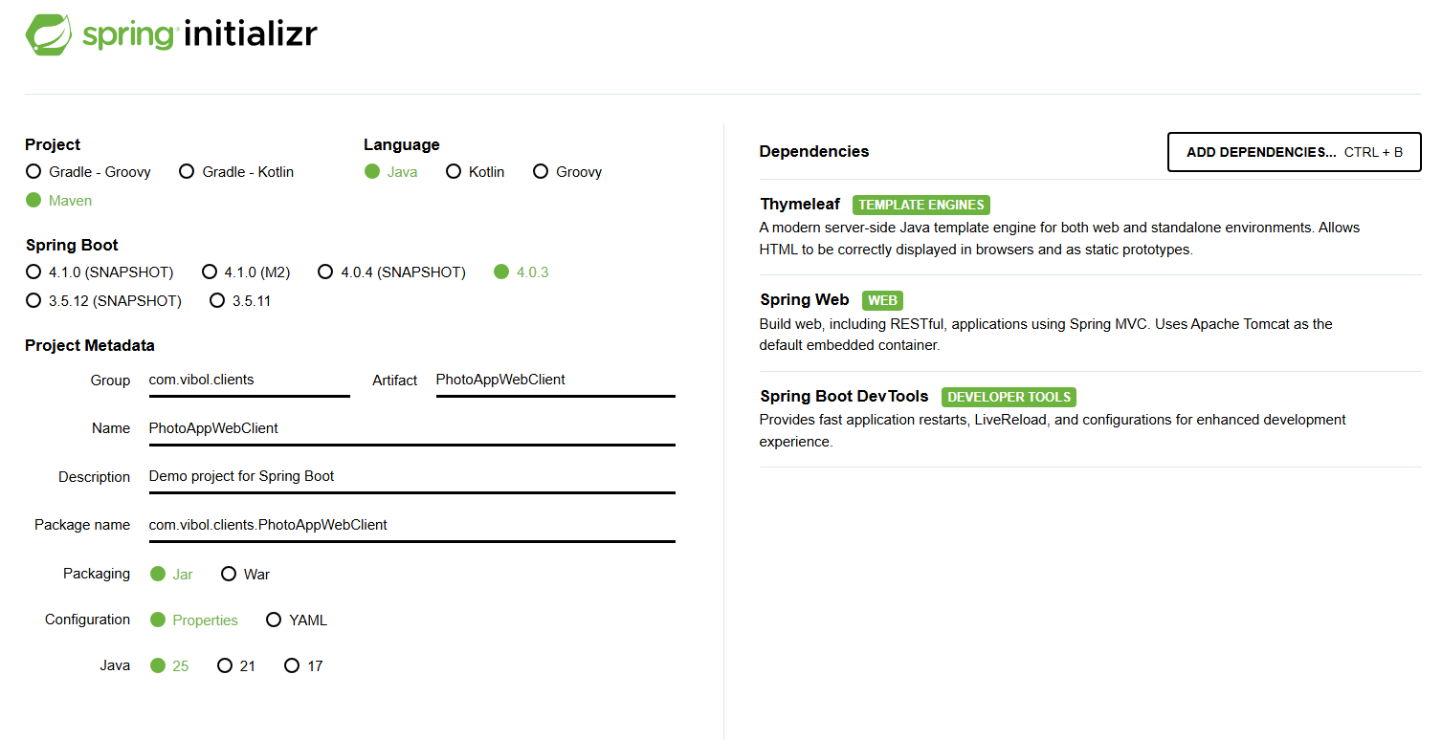

- Create html template: in the spring tool suite add Web

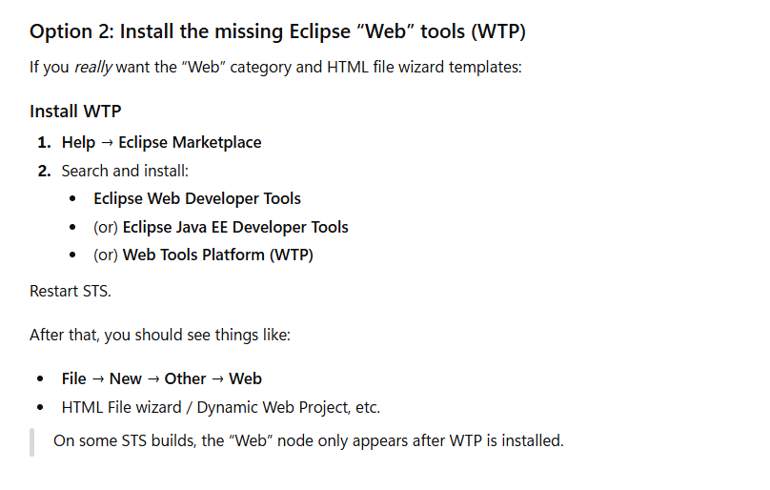
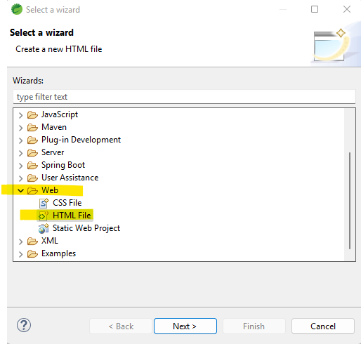

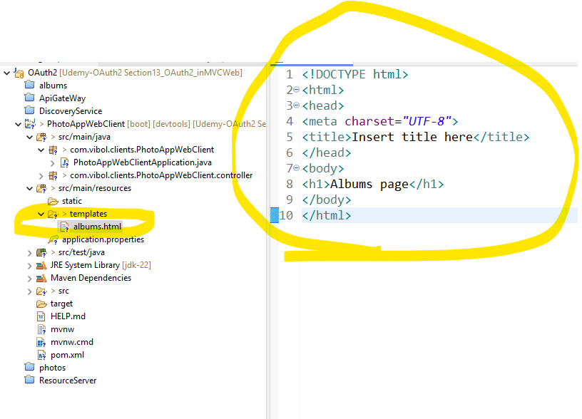

- Create Controller
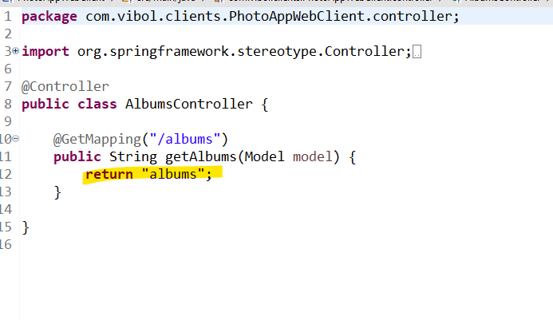

This return must be the same as template name (albums.hmtl).

- Display list in the web
4-1. Create object AlbumRest:

private String userId;
private String albumId;
private String albumTitle;
private String albumDescription;
private String albumUrl;

4-2. Create AlbumsController
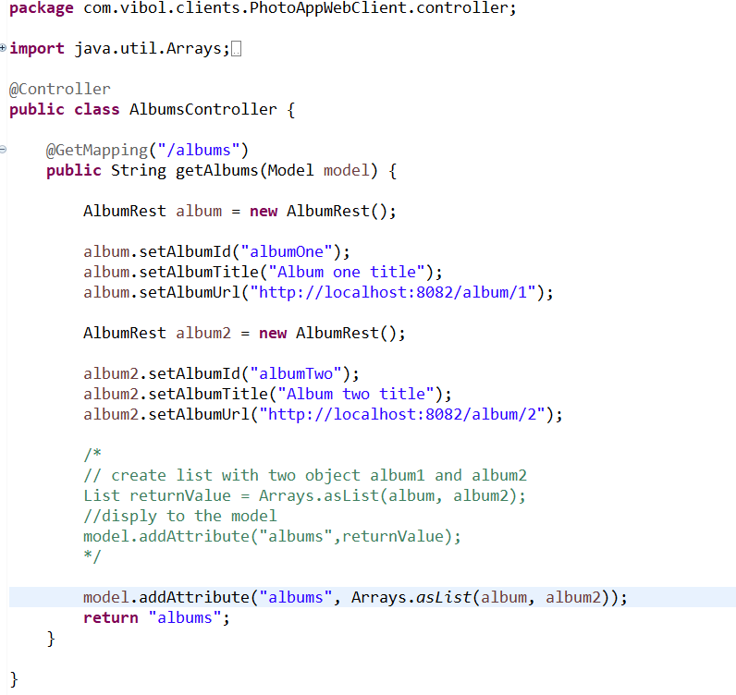

@Controller
public class AlbumsController {

@GetMapping("/albums")
public String getAlbums(Model model) {

AlbumRest album = new AlbumRest();

album.setAlbumId("albumOne");
album.setAlbumTitle("Album one title");
album.setAlbumUrl("http://localhost:8082/album/1");

AlbumRest album2 = new AlbumRest();

album2.setAlbumId("albumTwo");
album2.setAlbumTitle("Album two title");
album2.setAlbumUrl("http://localhost:8082/album/2");

/*
// create list with two object album1 and album2
List returnValue = Arrays.asList(album, album2);
//disply to the model
model.addAttribute("albums",returnValue);
*/

model.addAttribute("albums", Arrays.asList(album, album2));
return "albums";
}

}

